A picture containing clipart

Description generated with very high confidence

Azure 103 Module 4

Hands On - 9

Azure Certification Training

[**support@intellipaat.com**](mailto:support@intellipaat.com)

**+91-7022374614**

**US: 1-800-216-8930(Toll Free)**

**Azure 103 Module 4 , Hands On – 9**

**Attach NIC to VM**

**Step 1:** Open the VM in Azure portal and Click on Networking.

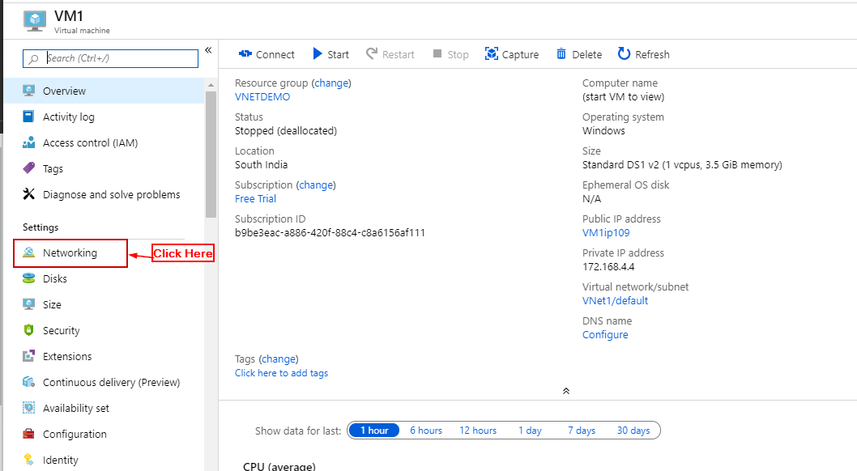

**Step 2:** Click on Attach Network Interface

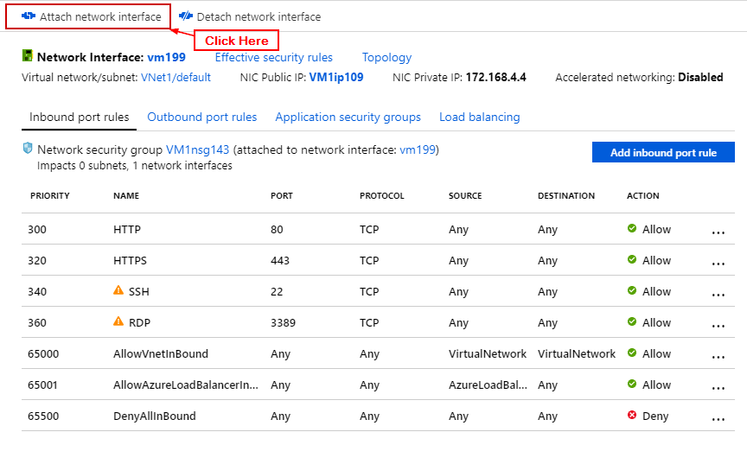

**Step 3:** Enter details and Click OK.

